Chapter 15, Problem 33.

Calculate the inverse Laplace transform of:

(a) 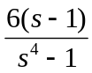
(b) 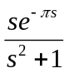
(c) 